# This article is about the OT-One.

## **It's no-longer sold or actively supported by Opentrons, but we've kept this article here to help existing users. Please** [**see our OT-2 Support articles**](https://support.opentrons.com/) **for the most up to date information!**

The first and most exciting thing to do with your OT-One liquid handler is to make it move!

If you haven't already, you will need to [download and install our free app](http://support.opentrons.com/getting-started/how-to-run-protocols/downloading-the-ot-app). Once installed, open the app and you will be shown the calibration screen.

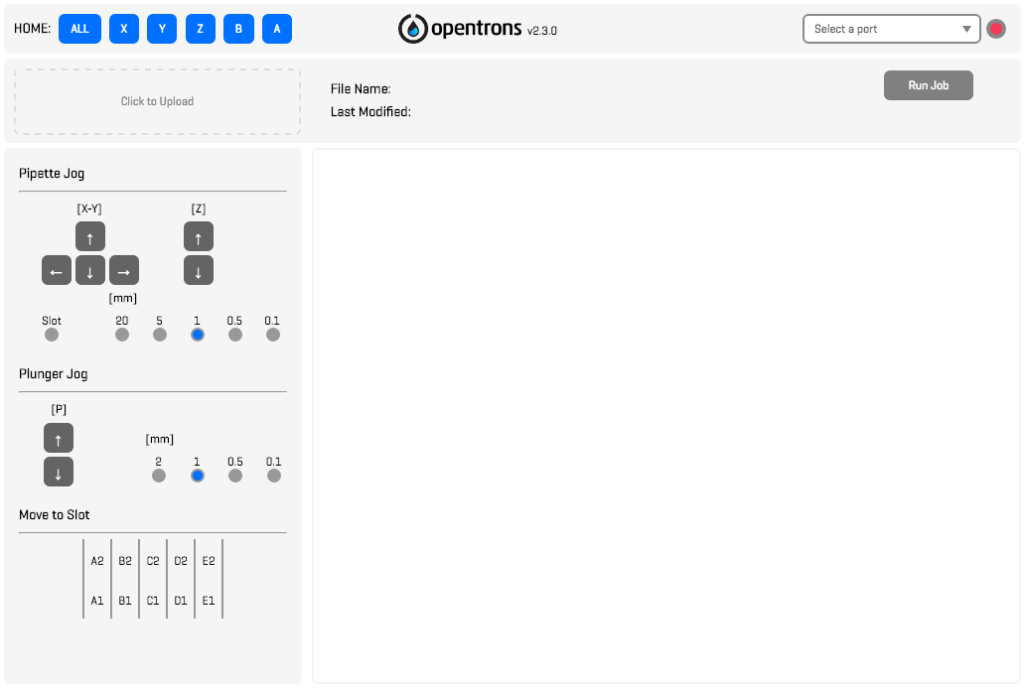

With the app open, connect your robot to power by plugging the provided power adapter into the appropriate port. Then, connect your computer's USB-A port to the OT-One’s USB-B port. Press the power button.

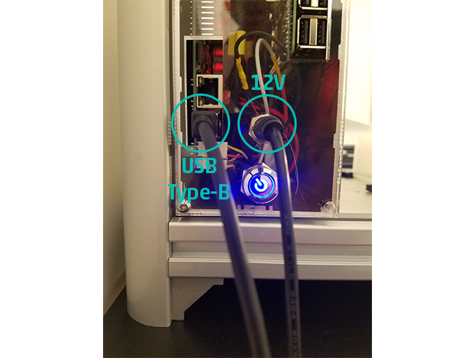

Once connected to the power supply, the power button will light up blue when pressed, meaning that your robot’s motors are receiving power.

To connect over USB, simply select the robot’s serial port from a dropdown menu in the top-right corner of the app’s screen.

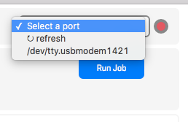

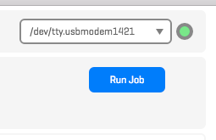

*The name of the port depends on your operating system. On Windows laptops, serial ports are given names that look like “COM3”, or “COM5”, or some other number, while on OSX it will look more like “/dev/tty.usbmodem1412”, or something similar.*

You can press “refresh” to update the list of serial ports if you do not see your robot’s port. Once there, select it from the menu to connect.

The app will then ask you if you would like to “home” the robot. Select “OK” and the robot will move to the default homing position.

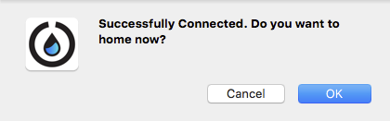

The robot will slowly move to the machine’s top-left corner, searching for specific switches. This is a very important step for your robot, because those switches are the only way your OT-One can accurately know its location.

At any time, you can home your robot by pressing one the blue "HOME" buttons in the top-left corner of the app. Test these out to see what happens!



Once you've been able to successfully home your robot, you are now ready to [download](https://support.opentrons.com/getting-started/how-to-run-protocols/downloading-protocols), and [run your very first protocol](https://support.opentrons.com/getting-started/how-to-run-protocols/upload-and-run-your-first-protocol)!